October 23-27, 2017

“Your Future is Key, So Stay Drug Free!”

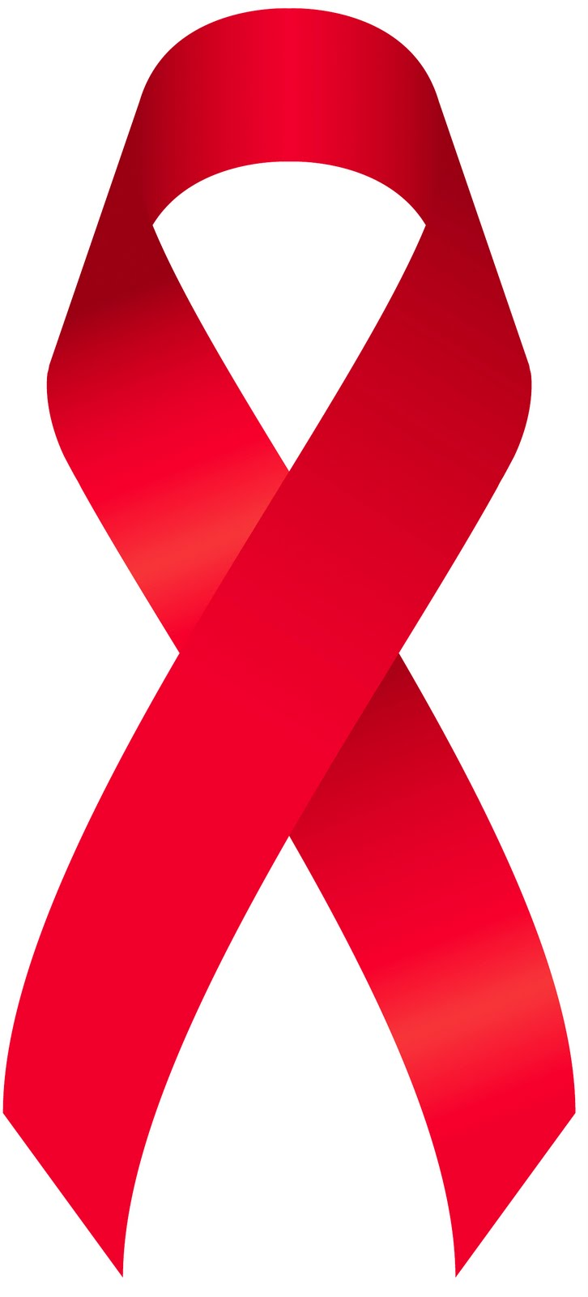
Monday, October 23rd: “Pledge to be Drug-Free!” – Wear red to school

Tuesday, October 24^{th:} “Team Up Against Drugs” – Wear your favorite team gear

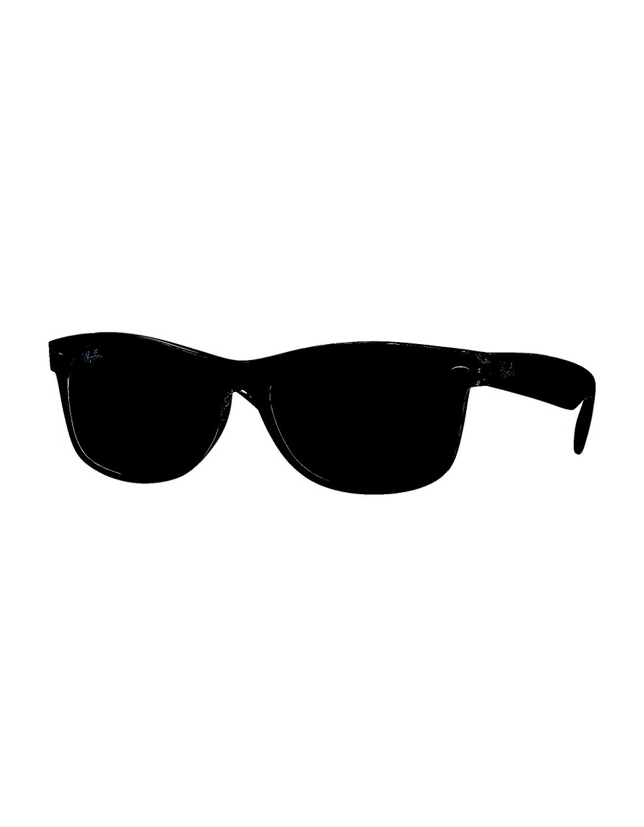

Wednesday, October 25^{th:} “Shade Out Bullies”– Wear sunglasses

Thursday, October 26^{th:} “Put a Cap on Drugs” – Wear a hat to school

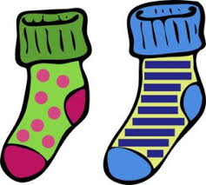
Friday, October 27^{th:} “Head to Toe, I’m Drug-Free” - Wear crazy hair and socks

